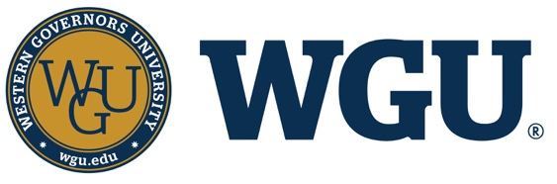
WGU News – For Immediate Release

<Graduate’s City> Resident Earns Degree from WGU

SALT LAKE CITY — (Today’s Date) <Graduate’s First Name, Last Name> of <Graduate’s City, State> (<Zip>) has earned <his/her> <Program Name> degree from Western Governors University (WGU). The online, nonprofit university recently held its <SUMMER or WINTER or SPRING or FALL or VIRTUAL> Commencement in <CITY, STATE>

WGU has recognized more than 25,000 degree recipients, who have completed their degrees since the beginning of the year. Their areas of study include business, K-12 education, information technology, and health professions, including nursing. The average time to graduation for those earning a bachelor’s degree was 2 years, 5 months, while the average time to degree for graduate programs was 1 year, 7 months. The average age for those who graduated is 38 years old.

WGU pioneered competency-based education, which measures learning rather than time spent in class. Designed to meet the needs of working adults, students study and learn on their own schedules with individualized, one-to-one faculty support. They complete courses as soon as they demonstrate that they have mastered the subject matter; allowing them to move quickly through material they already know so they can allocate time for what they still need to learn. As a result, many WGU students are able to accelerate their studies, saving both time and money.

About WGU
Established in 1997 by 19 U.S. governors with a mission to expand access to high-quality, affordable higher education, online, nonprofit WGU now serves more than 130,000 students nationwide and has more than 240,000 graduates in all 50 states. Driving innovation as the nation’s leading competency-based university, WGU has been recognized by the White House, state leaders, employers, and students as a model that works in postsecondary education. In 25 years, the university has become a leading influence in changing the lives of individuals and families, and preparing the workforce needed in today’s rapidly evolving economy. WGU is accredited by the Northwest Commission on Colleges and Universities, has been named one of Fast Company’s Most Innovative Companies, and was featured on NPR, NBC Nightly News, CNN, and in The New York Times. Learn more at www.wgu.edu.

